Press Release
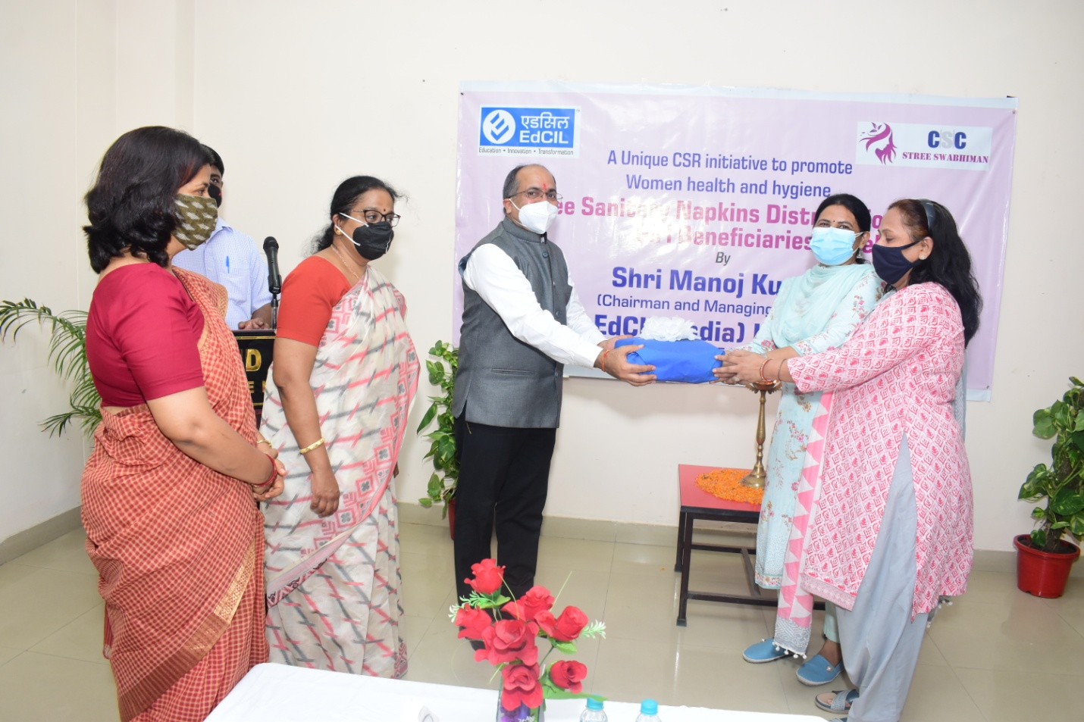
Sh. Manoj Kumar, CMD, EdCIL (India) Limited, (CPSE under Ministry of Education), launched the CSR initiative to promote Women Health and hygiene through “Free Sanitary Napkins distribution to girl beneficiaries in Govt. Schools in Delhi NCR” at National Institute of Empowerment of Persons with Intellectual Disabilities (NIEPID), NOIDA on 24th June, 2021. Ms. Amrita Sahay, Officer-In-Charge, NIEPID with teachers and staff and Ms. P. Jayanthi, GM (CSR) & officials from EdCIL were present on the occasion.

