Press Release
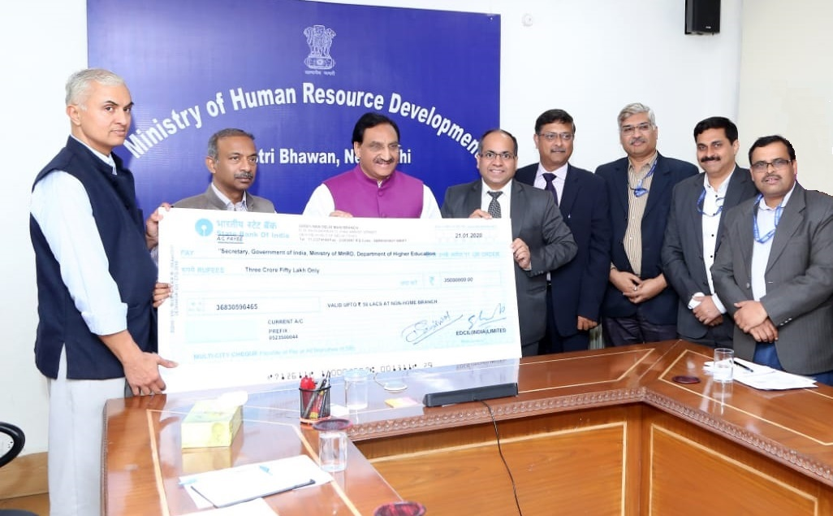
EdCIL (India) Limited, a Mini Ratna Category-I CPSE under Ministry of HRD, Government of India, paid a dividend of Rs 9.5 Crore for the year 2018-19.
Shri Ramesh Pokhriyal Nishank, Minister of Human Resource Development received the dividend cheque from Shri Manoj Kumar, CMD - EdCIL, in the presence of Shri Amit Khare, Secretary (MHRD) and Dr. Rakesh Sarwal, Additional Secretary (Technical Education) and senior officials of EdCIL.
The company registered a turnover of Rs. 317.27 Crore and a PBT of Rs. 43. 79 Crore during the year 2018-19.
EdCIL offers Project Management and Consultancy solutions across education verticals covering ICT/IT Solutions, Online Testing and Assessment Services, Advisory Services, Infrastructure, PMC, Procurement and Overseas Education Services.
The company is executing a mega-project of Ministry of HRD called “Study in India” to increase the number of inbound foreign students to India. The program includes setting-up of a large portal, call centre, social media campaign, branding, event management and setting-up of facilitation centres.

