Press Release

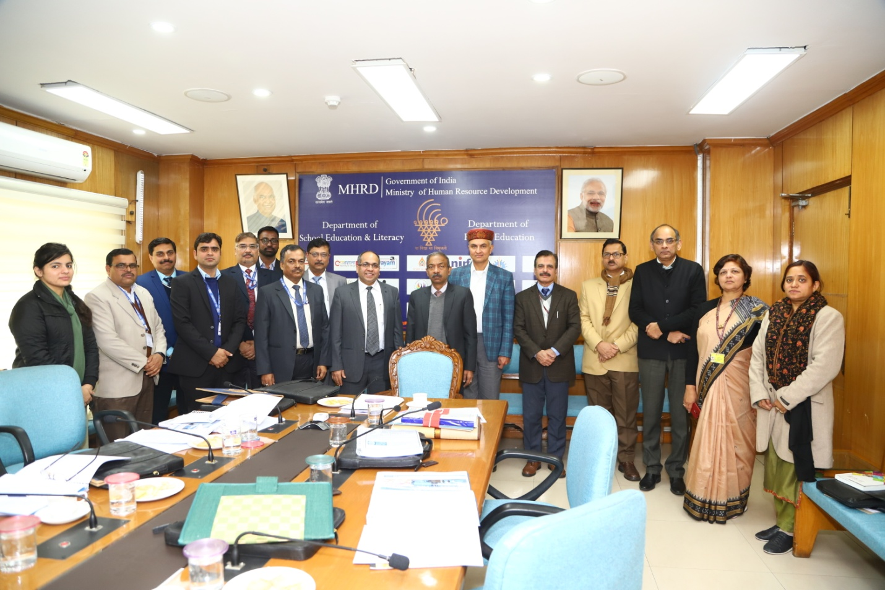
EdCIL held its 38th Annual General Meeting on 26/12/2019
The 38th Annual General Meeting (AGM) of EdCIL (India) Limited, a Mini Ratna Category – I CPSE, was held on 26th December, 2019 at Shastri Bhawan, New Delhi under the Chairmanship of Shri Amit Khare, Secretary (HE), MHRD in the presence of Dr. Rakesh Sarwal, AS(HE) and other senior officials of MHRD and EdCIL.
Shri Manoj Kumar, CMD, EdCIL outlined the achievements of the company during FY 18-19. The Company during FY 18-19 registered highest ever turnover of Rs. 317 crores which is 10% higher than the previous year turnover. The PBT was recorded Rs. 43 crores. The company has built up a robust order book and is poised to register higher growth in the year 2019-20.
EdCIL also declared a dividend of Rs 9.5 crores (including already paid interim dividend of Rs 6 crore) during FY 18-19.

