Press Release

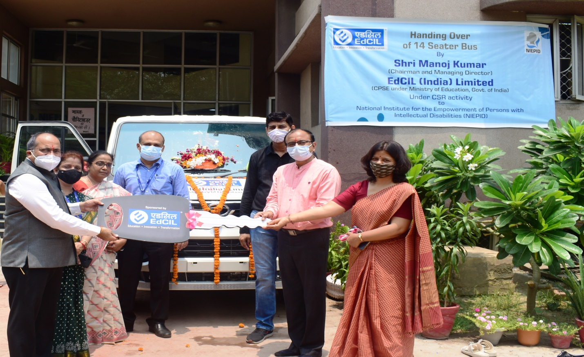
Sh. Manoj Kumar, CMD , EdCIL (India) Limited (A Mini Ratna CPSE, under Ministry of Education, Govt. of India) handed over a 14 seater TATA WINGER school bus to National Institute of Empowerment of Persons with Intellectual Disabilities(NIEPID), NOIDA on 24th June, 2021 under its CSR initiative. Dr. Hemant Singh Keshwal, Principal in-Charge , Ms. Amrita Sahay, Officer In Charge and teachers and staff of NIEPID and officials from EdCIL were present on the occasion. The students and their families and staff witnessed online streaming of program.

